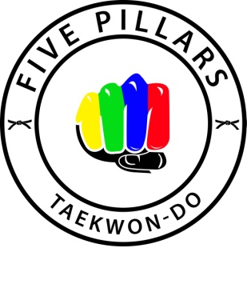
BLUE BELT GRADING RED TAG GRADING
Please note that students will be tested to perform the following set of exercises:
Requirements:
Juniors under 12
Blue = 20 press ups, Sit ups, Star Jumps, Plank, Standing Squats.
Teenagers + Adults
Blue = 30 press ups, Sit ups, Star Jumps, Plank, Standing Squats.

JOONG-GUN (32 movements):
JOONG- GUN is named after the patriot An Joong Gun who assassinated Hiro Bumo-Ito, the first Japanese Governor-General of Korea, known as the man who played the leading part of the Korea-Japan merger. There are 32 movements in this pattern to represent Mr An’s age when he was executed in Lui Shung Prison in 1910.
TOI-GYE (37 movements):
TOI-GYE is the pen name of the noted scholar Yi-Hwang (16th century), an authority on neo-Confucianism. The 37 movements of the pattern refer to his birthplace on the 37 degree latitude.

TERMINOLOGY
- Name all focus levels and if possible in Korean.
- Identify all motions
- Translate into Korean 5 stances of your choice
- Define the term pattern
- Explain why there are 24 patterns

